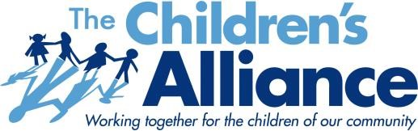

January 7th - Monthly Membership Meeting Agenda

Welcome & Introductions
- Brief member introductions
- Calls for collaboration, partnership needs, and announcements

Community Spotlight: Healthy Blue NC Rollout
Topic: What’s changing—and what it means for the children and families we serve
Presenters:
Healthy Blue Team – Dr. Keith Cradle, Sabrina Clark, Heather Johnson
Foster Family Alliance of North Carolina – Kate Peterson

Community Update: Juvenile Detention in Mecklenburg County
- Current status and recent developments
- Advocacy efforts and opportunities for member engagement

Looking Ahead: The Children’s Alliance – 2026 Focus
- Looking ahead for our 2026 Focus
- January Dues

Adjourn

Upcoming Member Event
1/22 Youth Mentoring Summit – Hosted by Big Brothers Big Sisters of Central Carolinas
https://form-renderer-app.donorperfect.io/give/big-brothers-big-sisters-of-central-carolinas/youth-mentoring-summit-2025
